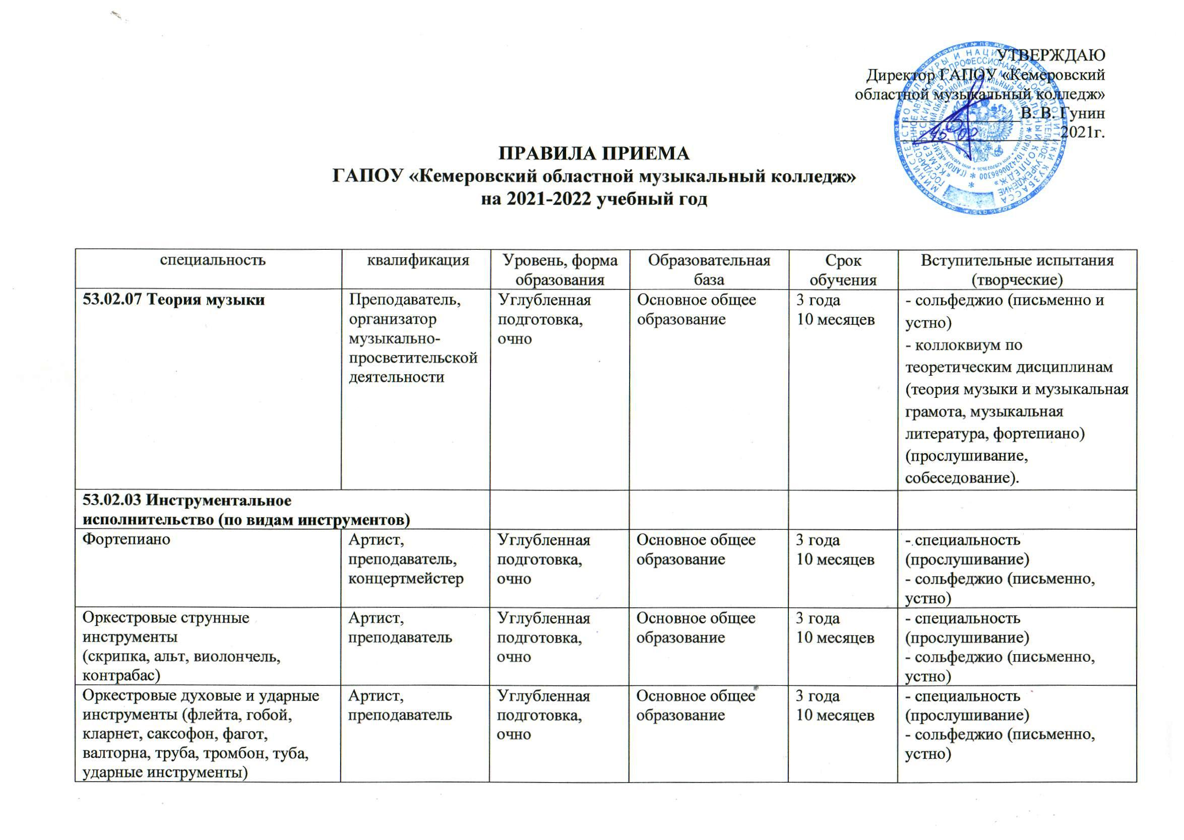

|  |  |
| --- | --- |
| **C:\Users\2\Desktop\Сброс\2 стр правил приема.jpg** |  |